**Build your own mine task**

A vein of ore containing gold has been found about 100m underground in the bed rock about a kilometer from the end of Graham Street, in Hannans. There seems to be large quantities in the vein so it is worth setting up a mine to get the ore out. The local government has given permission for the mine to go ahead on the grounds that the site is returned back to its original habitat once the mine closes.

In groups think about what the mining company will have to consider to actually mine the site the site and get the gold out. And be able to return the site back to its original state as close as possible.

Below is a cross section of the land where the vein is located.

**Native vegetation**

**Top soil** – 100-200mm

**Subsoil** – 200mm

**Oxide** – material below the soil containing lots of salt (not suitable for plant growth)

**Transitional layer** - from oxide ~~soil~~ to rock (contains high levels of salt)

**Rock layer** where the ore vein can be found

**Question 1**

What information (called base line data) do you think you going to need to collect before mining can begin about:

* the landscape
* the layers
* the amount of gold
* equipment and people

You need this data to be able to compare before and after and to understand what you are trying to rehabilitate back to

**Question 2**

To get the gold out you are going to have to use an open pit mining method similar to the Superpit but not as deep. There are several things you are going to have to think about before you start digging otherwise you could cost your company lots of money when it comes to rehabilitating your site. There are also things that will need to be considered to ensure the safety of your workers and the town that is close to your proposed mine site.

1. What things will you need to consider before you start digging down to get to the ore?

(Think about the fact you have to rehabilitate the site afterwards and there is a lot of material between you and the ore that has to be moved).

1. What things will you have to consider to ensure your workers are safe whilst digging and moving the material around?
2. What things will you need to consider to keep the town close by happy and safe?

**Question 3**

Before the mine can close it has to meet the criteria laid out by ~~Local~~ Government when the permission was granted to mine. How do you think a mine would go about meeting this requirement?

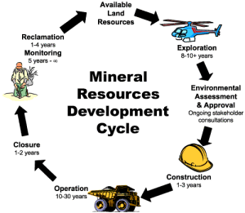

The basics of open pit mining:

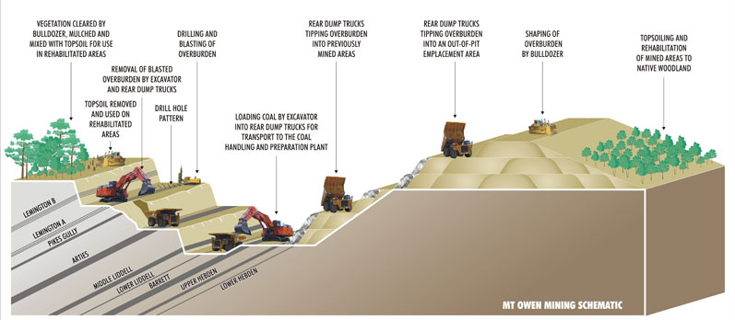

Use the resources to show how open pit mine actually works. The go into Biscuit mining to teach about the economic of mining, keeping your waste footprint to a minimum, the importance of quality ore and rehabilitation.

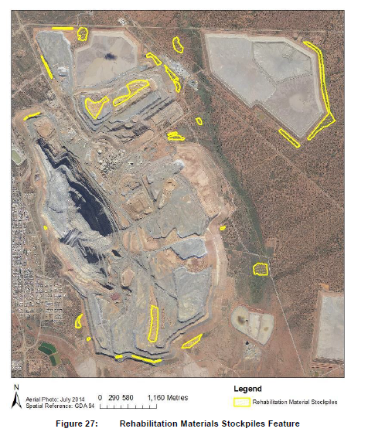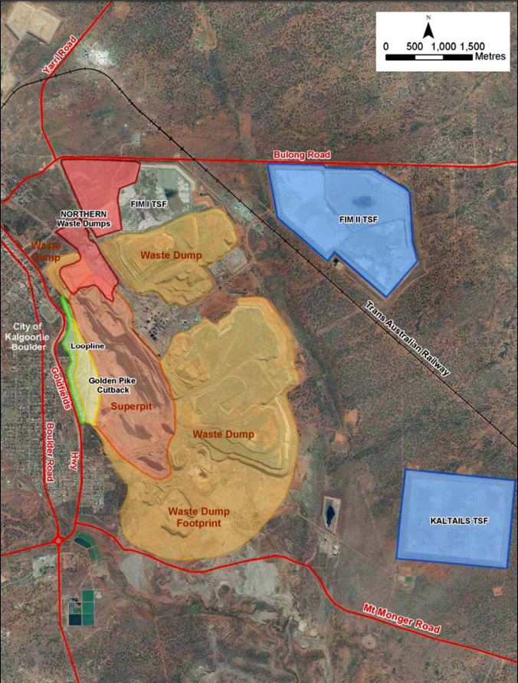First a space has to be found to store the top soil and subsoil for the rehabilitation process.

When KCGM was designed space had to be made to put all the material that was being dug out from the pit. This included the Oxide which is not suitable for plant growth and the waste rock that surrounds the useable ore. This waste rock is dug out and then transported to the waste rock dumps.

**How the open pit mine functions**

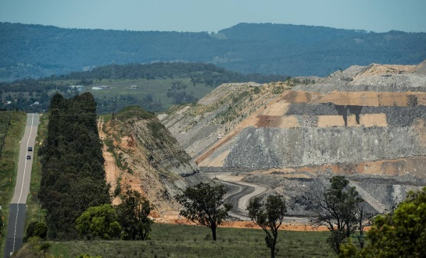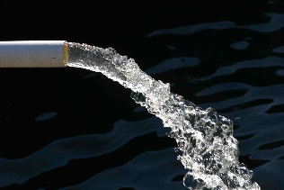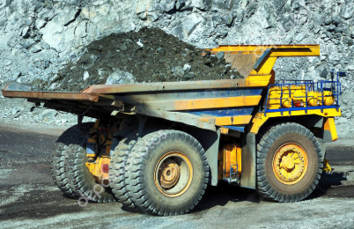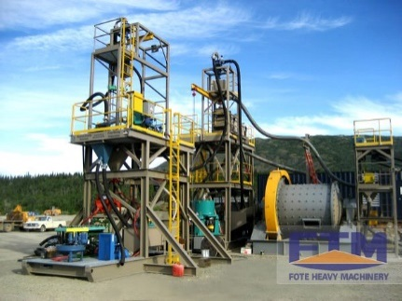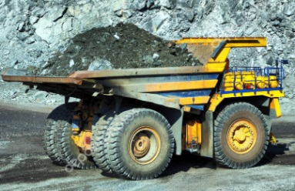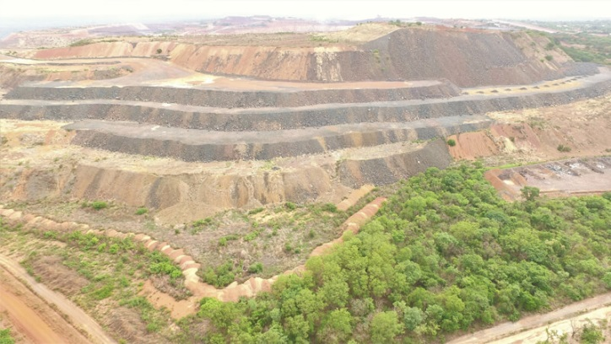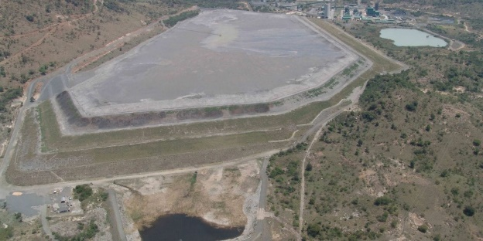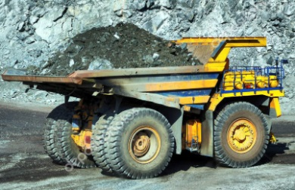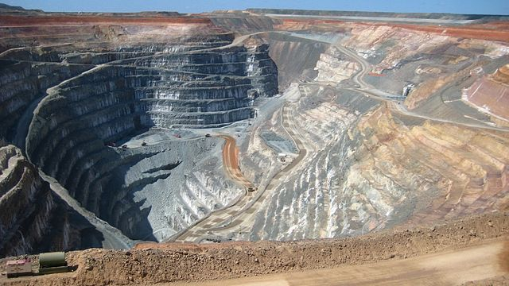**The Pit**

Product

Ore sent to mill to process

Ore dig out

Low grade ore collected and stockpiled

Waste rock dug out

Sent to stock pile as may

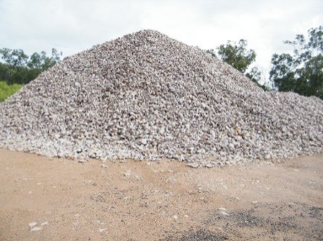 become useful

Waste after milling is a fine slurry – fine rock and water

Sent to tailings dam, water collected for re-use in the processing plant

Goes to waste dump built to specific shape

Waste dump reshaped, covered top soil and seeded